

OPC Test Lab Specification
Part 4: Certification Process Manual
Release Candidate Version 1.00.01
January 24, 2007
Send comments to:
ComplianceComments@opcfoundation.org

Specification Type | Industry Standard Specification
Title: | OPC Test Lab Specification  Part 4: Certification Process Manual | Date: | January 24, 2007
Version: | Release Candidate 1.00.01 | Software | MS-Word
 |  | Source: | 0000.doc
Author: | OPC Foundation | Status: | Release Candidate

CONTENTS

Page

FOREWORD iv
AGREEMENT OF USE iv
1 Scope 1
2 Reference documents 1
3 Terms, definitions, and conventions 1
3.1 OPC Test Lab Part 1 terms 1
3.2 OPC Test Lab Part 2 terms 1
3.3 OPC Test Lab Part 3 terms 1
3.4 Certification Process terms 2
3.4.1 Test Exception 2
3.5 Abbreviations and symbols 2
4 Product registration for test 2
5 Product certification in Certification Test Lab 4
5.1 Test preparation 4
5.2 Test execution 5
5.3 Test result 6
6 Test exceptions 7
7 Enhancement of test 8
8 Certificate and logo process 9
8.1 Compliance Logos and Certificates 9
8.2 Requesting a Logo 10
8.3 Compliance Logo Text 10
8.3.1 General Requirements 10
8.3.2 Certified Compliance Test 10
8.3.3 Self Compliance Test 10
8.4 Certification Logos 11
A.1 Appendix A 11
A.2 Appendix B 15

Figures
Figure 1 – Product Registration Process 2
Figure 2 – Test Preparation Process 4
Figure 3 – Test Execution Process 5
Figure 4 – Test Result Process 6
Figure 5 – Test Exception Process 7
Figure 6 – Test Enhancement Process 8
Figure 7 – Test Environment Update 9
Figure 8 – OPC Certification Logos 11

OPC Foundation
____________

OPC Test Lab Certification

FOREWORD
This specification is intended for developers and users of the OPC Certification Test Lab. Its goal is to define a certification process to ensure interoperability between OPC server and client products.
Copyright © 2006, OPC Foundation, Inc.
AGREEMENT OF USE
COPYRIGHT RESTRICTIONS
Any unauthorized use of this specification may violate copyright laws, trademark laws, and communications regulations and statutes. This document contains information which is protected by copyright. All Rights Reserved. No part of this work covered by copyright herein may be reproduced or used in any form or by any means--graphic, electronic, or mechanical, including photocopying, recording, taping, or information storage and retrieval systems--without permission of the copyright owner.
OPC Foundation members and non-members are prohibited from copying and redistributing this specification. All copies must be obtained on an individual basis, directly from the OPC Foundation Web site
http://www.opcfoundation.org.
PATENTS
The attention of adopters is directed to the possibility that compliance with or adoption of OPC specifications may require use of an invention covered by patent rights. OPC shall not be responsible for identifying patents for which a license may be required by any OPC specification, or for conducting legal inquiries into the legal validity or scope of those patents that are brought to its attention. OPC specifications are prospective and advisory only. Prospective users are responsible for protecting themselves against liability for infringement of patents.
WARRANTY AND LIABILITY DISCLAIMERS
WHILE THIS PUBLICATION IS BELIEVED TO BE ACCURATE, IT IS PROVIDED "AS IS" AND MAY CONTAIN ERRORS OR MISPRINTS. THE OPC FOUDATION MAKES NO WARRANTY OF ANY KIND, EXPRESSED OR IMPLIED, WITH REGARD TO THIS PUBLICATION, INCLUDING BUT NOT LIMITED TO ANY WARRANTY OF TITLE OR OWNERSHIP, IMPLIED WARRANTY OF MERCHANTABILITY OR WARRANTY OF FITNESS FOR A PARTICULAR PURPOSE OR USE. IN NO EVENT SHALL THE OPC FOUNDATION BE LIABLE FOR ERRORS CONTAINED HEREIN OR FOR DIRECT, INDIRECT, INCIDENTAL, SPECIAL, CONSEQUENTIAL, RELIANCE OR COVER DAMAGES, INCLUDING LOSS OF PROFITS, REVENUE, DATA OR USE, INCURRED BY ANY USER OR ANY THIRD PARTY IN CONNECTION WITH THE FURNISHING, PERFORMANCE, OR USE OF THIS MATERIAL, EVEN IF ADVISED OF THE POSSIBILITY OF SUCH DAMAGES.
The entire risk as to the quality and performance of software developed using this specification is borne by you.
RESTRICTED RIGHTS LEGEND
This Specification is provided with Restricted Rights. Use, duplication or disclosure by the U.S. government is subject to restrictions as set forth in (a) this Agreement pursuant to DFARs 227.7202-3(a); (b) subparagraph (c)(1)(i) of the Rights in Technical Data and Computer Software clause at DFARs 252.227-7013; or (c) the Commercial Computer Software Restricted Rights clause at FAR 52.227-19 subdivision (c)(1) and (2), as applicable. Contractor / manufacturer are the OPC Foundation,. 16101 N. 82nd Street, Suite 3B, Scottsdale, AZ, 85260-1830
COMPLIANCE
The OPC Foundation shall at all times be the sole entity that may authorize developers, suppliers and sellers of hardware and software to use certification marks, trademarks or other special designations to indicate compliance with these materials. Products developed using this specification may claim compliance or conformance with this specification if and only if the software satisfactorily meets the certification requirements set by the OPC Foundation. Products that do not meet these requirements may claim only that the product was based on this specification and must not claim compliance or conformance with this specification.
Trademarks
Most computer and software brand names have trademarks or registered trademarks. The individual trademarks have not been listed here.
GENERAL PROVISIONS
Should any provision of this Agreement be held to be void, invalid, unenforceable or illegal by a court, the validity and enforceability of the other provisions shall not be affected thereby.
This Agreement shall be governed by and construed under the laws of the State of Minnesota, excluding its choice or law rules.
This Agreement embodies the entire understanding between the parties with respect to, and supersedes any prior understanding or agreement (oral or written) relating to, this specification.

Scope
This specification provides the Certification Process descriptions for an OPC Independent Certification Test Lab to ensure the same test quality in all Certification Test Labs.
The interoperability of the member developed components, and the compliance of these components to the OPC specifications is critical to the success of the OPC Foundation and its members. In addition, quality, reliability, performance and ease of use are the key factors that will lead to increased use of OPC Interfaces in different branches of industry.
To help improve the quality, robustness and interoperability of OPC Client and Server products, this document defines the processes required for product certification in Certification Test Labs. This document is part of a multipart specification that serves as a base for the development and operation of Certification Test Labs. The certification process is addressed to the management and staff of Certification Test Labs, the management and staff of the OPC product vendors and the management of the OPC Foundation.

Reference documents
This document is Part 4 of the OPC Test Lab multi-part specification.

Terms, definitions, and conventions

OPC Test Lab Part 1 terms
The following terms defined in Part 1 of this multi-part specification apply
- Compliance Testing
- Compliance Test Tool
- Interoperability Testing
- Certification Testing
- Certification Test Lab

OPC Test Lab Part 2 terms
- OPC Server
- OPC Client
- Test Records
- Test Report

OPC Test Lab Part 3 terms
- Compliance Committee
- Compliance Director
- Customer

Certification Process terms

Test Exception
The process that occurs when an issue is raised during test where the Vendor and the Independent Certification Test Lab cannot agree as to the result of a test case.

Abbreviations and symbols
CTT | Compliance Test Tool
NDA | Non Disclosure Agreement
36H | A test that runs for an extent period of time (i.e. 36 hours). The actual time is defined in the individual test specification

Product registration for test
The product registration process describes the steps necessary to prepare a product for the testing and to register for a test in an Independent Certification Test Lab (see Figure 1).
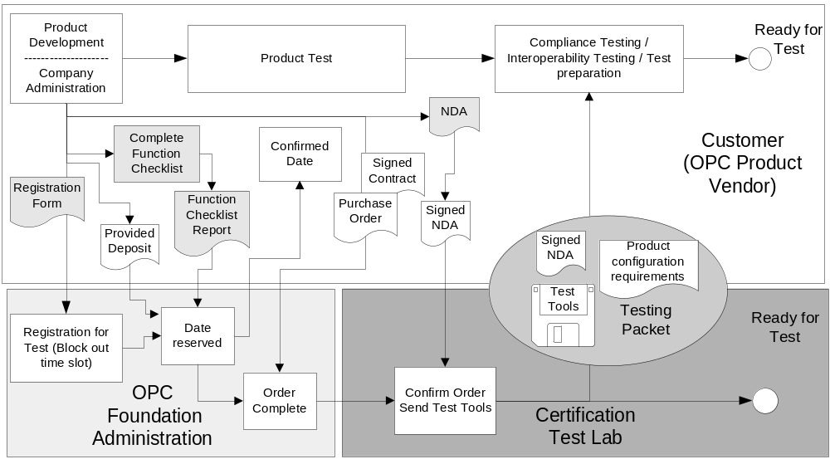
Figure 1 – Product Registration Process
The registration process can be started after product development in parallel to product testing. This will help to avoid delays in the product release process caused by scheduling problems in the Certification Test Lab. The following three steps required by the vendor can occur in any order, but all three must be completed before a timeslot is provided for the Independent Certification Test Lab.
The vendor must complete the on-line registration form. This form contains the product name, the requested date for certification, requested test lab location and vendor contact information. The vendor can also provide any comments regarding testing, such as name of additional vendor contacts, special request etc...
The Vendor must register the product, complete the checklist for the product and run the checklist report The Product registration, checklist and Checklist report are all available on-line. The checklist must state the supported OPC functionality; the amount of OPC related documentation, the desired setup time in the Independent Certification Test Lab and special requirements for the test environment such as hardware, power or software. The Checklist report provides an estimate of the testing duration. This report must be run with a completed checklist. It will automatically notify the test lab that product registration is complete. The function checklist depends on the tested specification.
The vendor sends a non-refundable deposit to the OPC Foundation to reserve an Independent Certification Test Lab time slot.
Based on the information provided the OPC Foundation will maintain a web page that shows open time slots in the test labs.
The Independent Certification Test Lab sends a template for a mutual non-disclosure agreement (NDA) to the Vendor, a contract for the testing and a general information packet. The NDA is just a template and any standard mutual non-disclosure agreement can be used. .A vendor can also decline requiring a NDA The Contract provides information regarding the term of test (see section A.2 for a sample). The general information packet include items such as local accommodations, Test Lab contact information, shipping information (in case any hardware needs to be shipped) etc.
The Vendor must provide a purchase order to the OPC Foundation for the estimated cost of the Independent Certification Test Lab test. The OPC Foundation will bill for this time even if the vendor does not attended. The vendor must cancel or reschedule a minimum of 4 weeks before testing. Any changes in the 4 week window could result in the vendor being billed for the un-used time. The Test Lab will make every effort to schedule some one else in the open time slot, but if no one is scheduled then the vendor is responsible for the time. The Vendor must provide the signed contract and may also provided a signed mutual NDA to the Certification Test Lab
Upon receipt, the Independent Certification Test Lab must confirm the order and send the test tools, the test instructions, the product configuration requirements and the signed mutual NDA (if provided by the vendor) to the Vendor. Based on this input the Vendor must prepare an appropriate configuration for the product to reduce the time required in the Certification Test Lab.
The Vendor must use the provided test tools during or after its product testing but before the certification starts in the Certification Test Lab. The Vendor must provide proof that the product has completed the self-testing and the tests using the tools provided by the Certification Test Lab. After completing the test with the provided test tools, the Vendor is ready to start the certification test for its product.

Product certification in Certification Test Lab

Test preparation
The test preparation process describes the steps necessary to be ready to start the product certification test in an Independent Certification Test Lab as illustrated in Figure 2.
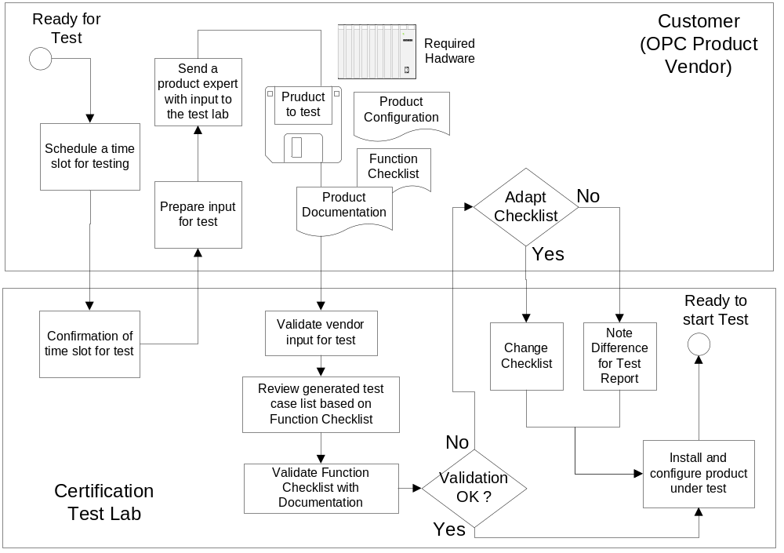
Figure 2 – Test Preparation Process
The test preparation starts with the Vendor scheduling a test slot in a Certification Test Lab. The scheduling can be done before the Vendor is ready for the test but the Vendor needs to ensure that they will be ready for the scheduled date. The Independent Certification Test Lab needs to confirm the scheduled time slot. A Vendor will be billed for the test lab time unless they cancel within the time frame specified, The deposit is not returned, it can be applied to another test period, if the period is within a calendar year of the original request date.
After the Vendor has its product ready for the test and has a confirmed time slot for certification testing, the Vendor can prepare all required input for the test that is needed in addition to the already provided function checklist. These inputs include the product to test, the product documentation, a product configuration that fulfils the requirements for the test and additional hardware such as devices needed during the test.
The Vendor will send these input items to the Certification Test Lab. The Independent Certification Test Lab will validate the input and validate the pre-created test case list based on the test cases for the tested interface and the function checklist for the product.
After preparing a test case list the Independent Certification Test Lab will validate the function checklist against the product documentation provided by the Vendor. It is recommended that the product documentation be provided prior to the actual testing to minimize this required review time. If the function checklist does not match the documentation, the Vendor may fix either the functional check list or the product documentation. If the documentation is provided in advance, the test lab will make every effort to provide feedback about any conflict to the Vendor prior to the actual testing. If the Vendor does not change either document, the difference will be documented as part of the Test Report. It is understood that product documentation may require some period of time to correct, and the Test Report can be amended after testing has completed, if the Vendor provides an updated version of the documentation to the test lab, prior to the actual publishing of the Test Report.
The product expert will arrive at the Independent Certification Test Lab and will assist in setup of the product for testing.
After installing and configuring the product under test in the Independent Certification Test Lab the environment is ready to start the certification test.

Test execution
The test execution process describes the steps necessary to run the product certification test in an Independent Certification Test Lab as illustrated in Figure 3.
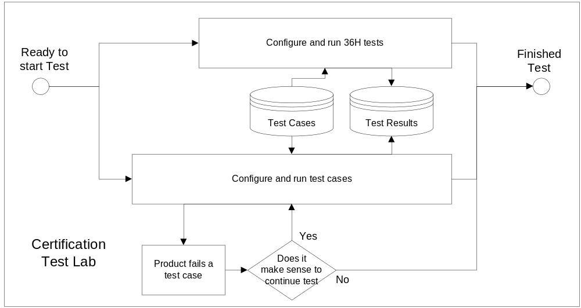
Figure 3 – Test Execution Process
When the test environment is ready to start the test, two parallel test threads will be started based on the test cases. One thread is the “36 hour” test that will run in parallel to other test cases. The other thread is the execution of all other test cases for the product being tested.
The test cases will be executed according to the list and the instruction in the test case list. The list is filtered based on the function checklist for the OPC Server or OPC Client.
For each test case, a test result must be recorded. Additional comments for product improvements can be added to the Test Records for further analysis by the Vendor after the test and will be provided as part of the Test Report.
If a product fails a test case, the Independent Certification Test Lab and the Vendor must decide if it makes sense to continue the test. The Vendor may finish the test cases to determine if there are any other open issues, but some general errors may make it impossible to execute the remainder of the test cases. In this case the test of the product may be terminated.
The test will be finished after executing all test cases or after failing a test case that validates base functionality.
The Vendor will be billed for the actual time duration of the test, less the deposit amount, upon completion of the testing.

Test result
The test result process describes the steps necessary to validate the test results and to issue a Test Report and a certificate if the product passed the certification test in an Independent Certification Test Lab as illustrated in Figure 4.
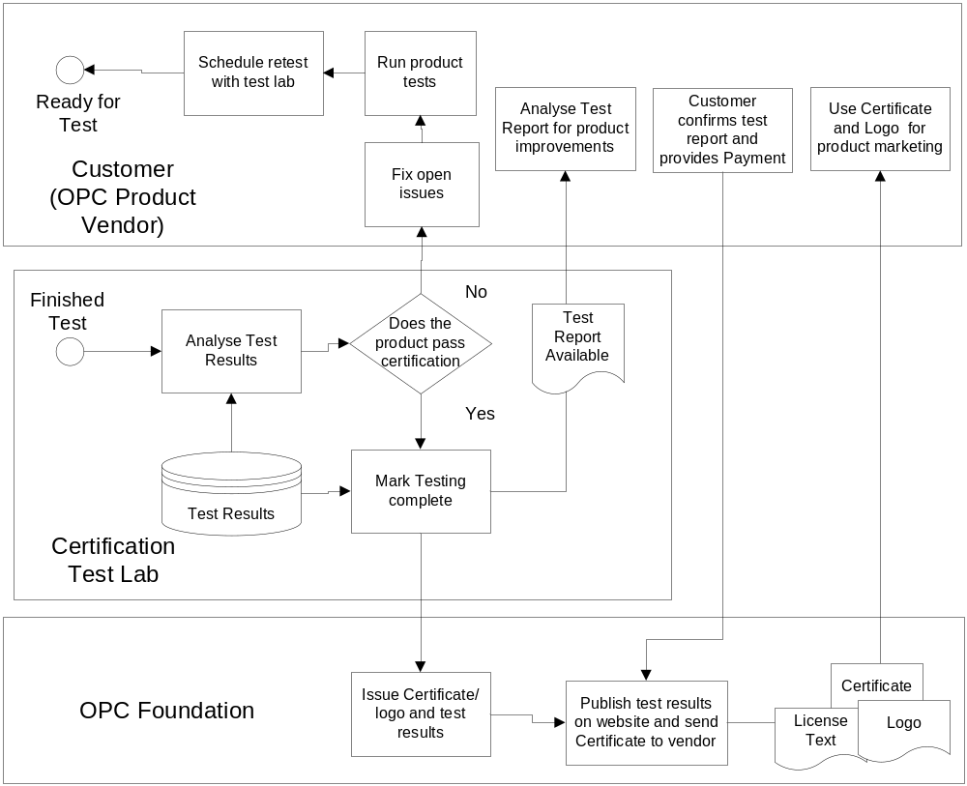
Figure 4 – Test Result Process
After finishing the certification test, the Independent Certification Test Lab must analyze the test results. If the product passed all certification test cases, the Independent Certification Test Lab will Mark the product as passing testing. It will notify the OPC Foundation and the Vendor. The product vendor can analyze the Test Report. A product may pass certification testing with warnings but excessive warning can cause a failure. Warnings exist in 4 levels. The Test lab makes the final determination with regard to warnings, but in general a product with more then 25% of the test case listed having a warning as a result, would not pass. If more then 3% of the test case have a level 4 warning then the product would not pass. If more than 10% level 3 & level 4 warning then the product would not pass and more then 18% level 2, level 3 and level 4 warnings then the product would not pass. The OPC Foundation and Compliance committee may refine these percentages and individual vendor can always appeal the percentage for a given product
The OPC Foundation will check the Test Report and once payment is received allow the vendor to obtain a Certificate and or Logo for the tested product. The Certificate/Logo status and Test Report will be published on the OPC Foundation web site. The certificate will be available to the vendor along with licensing instructions that explain how to use the Certificate/Logo and the Logo text that must be included in the product documentation and the license text related to the Logo. It is the vendor responsibility to complete the Certificate and logo process. This process is documented in Clause 8.
If the product fails one or more test cases or has excessive warnings, the Vendor must fix the open issues and retest the product outside of the Certification Test Lab. After testing the product the Vendor can schedule a retest in the Certification Test Lab.

Test exceptions
The test exception process describes the steps necessary to handle a test exception as shown in Figure 5.
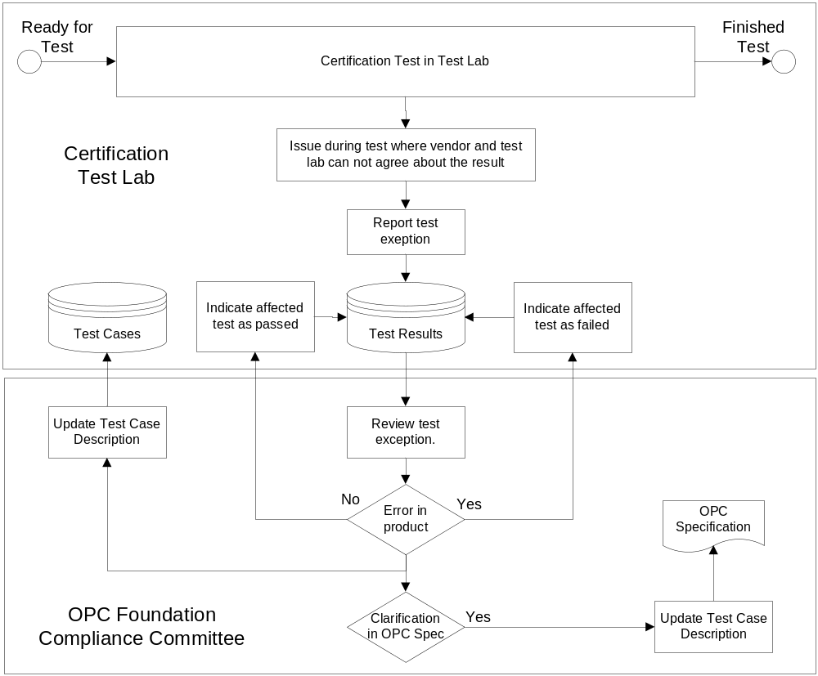
Figure 5 – Test Exception Process
The process for test exceptions will be triggered by any issue during the test that affects the results of a test case but that the Vendor and the Independent Certification Test Lab cannot agree on.
The test exception will be recorded in the Test Reports. The OPC Compliance Committee will decide the matter after reviewing the test exception at a regular meeting. The procedure is defined in part 3 of this multi-part specification.
If the OPC Compliance Committee decides that the behaviour of the product is not compliant with the expected behaviour the affected test case will be set to failed. The test case description will be updated to clarify the handling of the problem in case the problem occurs again.
If the OPC Compliance Committee decides that the behaviour of the product is compliant with the expected behaviour, the affected test case will be set to passed. The test case description will be updated to clarify the handling of the problem in case the problem occurs again.
In both cases the test specification or the affected OPC specification must be reviewed for additional clarification.

Enhancement of test
The test enhancement process describes the steps necessary to improve the test cases and test tools based on issues discovered during Certification Test or based on input from the Vendor as illustrated in Figure 6.
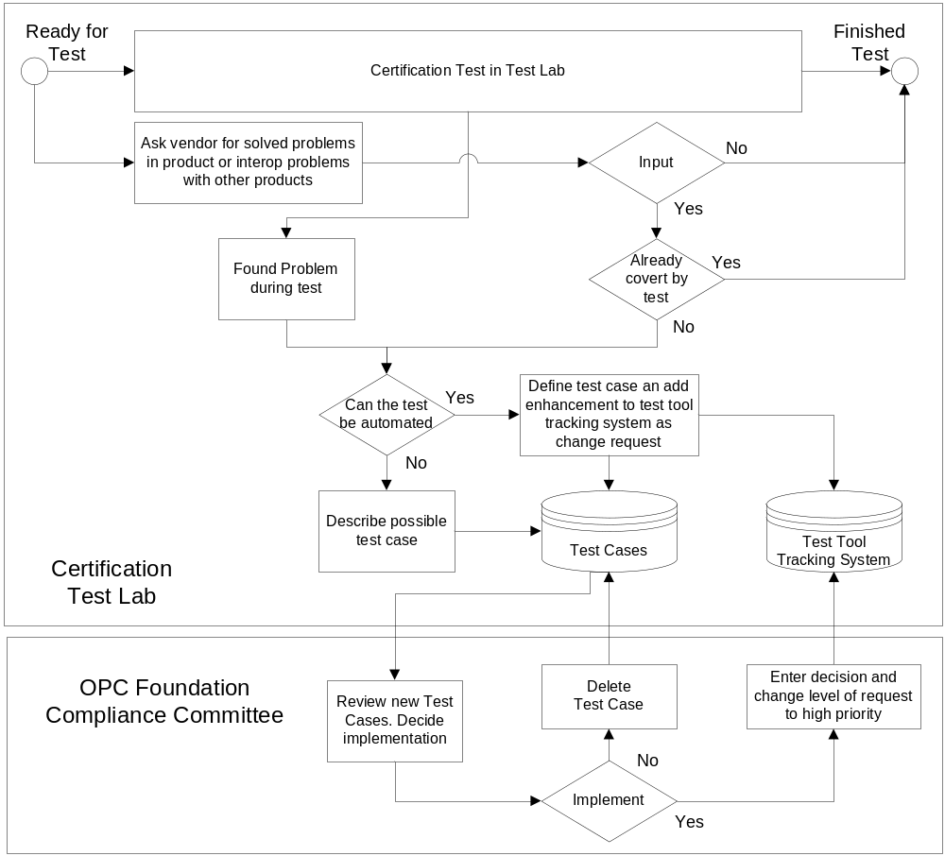
Figure 6 – Test Enhancement Process
The certification of products in an Independent Certification Test Lab should not only help to improve the quality of OPC products. It should also provide a systematic improvement of the certification test and the test tools used. The required input for the enhancement must have two sources. One source is issues found during the tests that are not covered by test cases and the other source is input from the Vendors joining the certification process. This important input from the Vendors should be based on already fixed problems in their product or known interoperability issues with other products. Additional input is also welcome.
Input from a Vendor is reviewed to check if it is already covered by a test case. For all new issues a test case must be defined and added to the test case database. If an automated test is possible, a change request must be added to the test tool that is able to handle such a test case. The requests are managed in a central bug tracking system that is available to all Certification Test Labs and to the Director of Compliance.
The OPC Compliance Committee must review new test cases during regular meetings and must decide if they are useful and should be implemented. The committee must also check the test specification and the affected OPC specification to determine if they need additional clarification. If the test case is useful, the implementation must be indicated for the affected test tools in the bug tracking system by changing the level of the request from change request to a priority based on the importance of adding the test case (low/medium/high). If the new test case is not useful for certification, the test case will be set to the state solved in the test case database. Low priority test case enhancements could be included in a major enhancement of the test, High priority test cases would be included as there own service release and medium priority test cases would be provided in periodic service packs.
Figure 7 shows the steps to update the test environment.
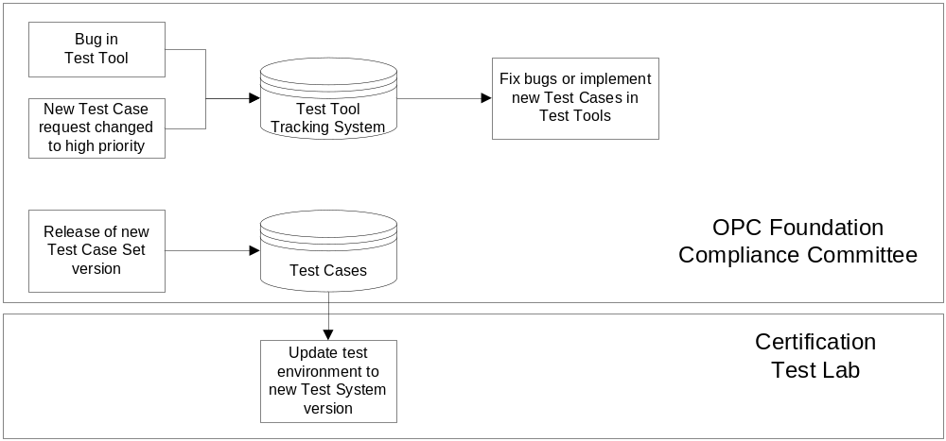
Figure 7 – Test Environment Update
New test cases should be implemented during normal maintenance of the test tools. This maintenance also includes bug fixes for the test tools.
The OPC Compliance Committee must decide when a new set of test cases and test tools should be released for use in the Certification Test Labs. The test case database has a version system for all test cases. There is an active version that is used in all Certification Test Labs. The next version contains improvements, clarifications and new test cases and is not used until the OPC Compliance Committee has released the next version. If the OPC Compliance Committee releases a new version, that version must be used by all Certification Test Labs and they must update their test environment with the latest test tools.
If there is a bug in the test tool that is currently used in all Certification Test Labs, the Independent Certification Test Lab can overwrite the result of the test case.

Certificate and logo process

Compliance Logos and Certificates
The OPC Foundation will provide Logos for all products that complete and pass Independent Certification Test Lab testing. In addition the OPC Foundation may also provide electronic signed certificates for use in product that require it (i.e. UA based products). The process for Obtain Certificates will be provided in a future revision of this document.

Requesting a Logo
The OPC Foundation WEB site provides a link for requesting a Logo. This link will generate n e-mail that will be process by the OPC Foundation and result in a logo being generated. The Logo package will include the logo described in section 8.4 and the text that is to be displayed with the logo in section 8.3, The package will also include a legal document that describe the vendor rights with regard to the logo; and example of this document is provided in section A.1

Compliance Logo Text

General Requirements
The following general text for the certification logos must be included in the vendor’s documentation when the OPC Certification logo is displayed. The actual text will be provided with the logo. Additional information should be included on the OPC web site and with the legal documents that are provided with the logo.

Certified Compliance Test
The OPC Foundation Certified Compliance Tested logo is a trademark of the OPC Foundation and may be used only by written permission of the OPC Foundation. Any unauthorized use of the Certified Compliance Tested logo is prohibited.
The OPC Foundation Certified Compliance Tested logo indicates that this product has been tested by an independent certification lab and is certified to be compliant with the following OPC Specifications:
{List applicable specifications}
Additional information about compliance testing, the logo program and a summary of test results for this product can be found at www.opcfoundation.org.

Self Compliance Test
The OPC Foundation Self Compliance Tested logo is a trademark of the OPC Foundation and may be used only by written permission of the OPC Foundation. Any unauthorized use of the Certified Compliance Tested logo is prohibited.
The OPC Foundation Self Compliance Tested logo indicates that this product has been tested by the manufacturer to be compliant with the following OPC Specifications:
{List applicable specifications}
Additional information about compliance testing, the logo program and a summary of test results for this product can be found at www.opcfoundation.org.

Certification Logos
Figure 8 shows the certification logos for Self Compliance Tested and for Certified Compliance Tested.
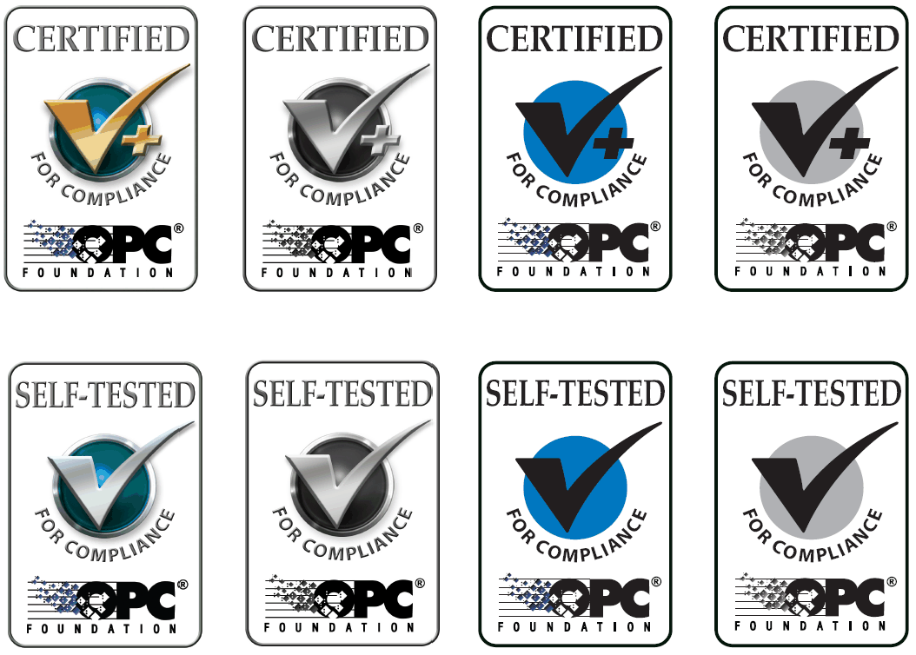

Figure 8 – OPC Certification Logos

  - Appendix A
This appendix provides a sample of the legal text that will be provided with all logos

OPC FOUNDATION COMPLIANCE
LOGO LICENSE AGREEMENT \

THIS AGREEMENT is between OPC Foundation, (“FOUNDATION”) a non-profit corporation of Minnesota, having a principal office at 16101 N. 82nd Street, Scottsdale, Arizona 85260 and _________________________________________________ (“COMPANY”) having a principal office at ____________________________ _____________________________, a member of the OPC Foundation.
WHEREAS, the FOUNDATION owns the OPC Foundation compliance logo marks (“LOGOS”) shown in EXHIBIT A, which are used only by its members to identify computer software products that have been tested and certified under the standards and specifications established by the FOUNDATION.
COMPANY desires to use the LOGOS and FOUNDATION desires to license to COMPANY the rights to use the LOGOS subject to the following terms and conditions.
NOW, THEREFORE, in consideration of the promises and agreements set forth herein, the Parties each intending to be legally bound hereby, do promise and agree as follows:
- 1. LICENSE. FOUNDATION hereby grants to COMPANY for the Term of this Agreement the nonexclusive right to use the LOGOS worldwide solely for the limited purpose identified herein, and solely in association with the software products identified in EXHIBIT B (“Products”).
- 2. USE OF LOGOS. COMPANY agrees to use the LOGOS only with the Products, identified in EXHIBIT B, as long as it meets the FOUNDATION’s technical and procedural compliance-testing standards and has gone through the compliance-testing process. For every new product or new version of the Products, COMPANY must pass the compliance-testing process and complete a new Agreement for authorization to use LOGOS with products other than Products identified in EXHIBIT B. Further:
  - a. COMPANY agrees that it shall not modify the LOGOS or combine it with another mark, or register any marks confusingly similar to the LOGOS.
  - b. COMPANY agrees to ensure that use of the LOGOS are not detrimental or harmful to FOUNDATION and does not damage the goodwill in the LOGOS.
  - c. COMPANY agrees to ensure that the LOGOS are used in a manner which significantly distinguishes it from any surrounding adjacent text or other logos. The size and placement of the LOGOS must emphasize clearly that the COMPANY is an independent entity and not associated with the FOUNDATION in any manner other than being a member of the FOUNDATION.
  - d. COMPANY agrees that the LOGOS may not be included in or on any product, trade dress, design or service name that is not compliance-tested and verified as compliance-tested by FOUNDATION. The LOGOS awarded to a company for its products, may be displayed on a company related WEB site or documentation that does not directly reference any products. The LOGOS may not be displayed in any manner that could imply that products other than the compliance-tested product have been compliance-tested.
  - e. COMPANY agrees to use the standard text found in EXHIBIT C on the packaging of its Products, by displaying the text near the LOGOS to identify the OPC specifications for which the Products have been compliance-tested.
  - f. COMPANY agrees to ensure that all of its advertising, web sites, promotional and other materials which bear the LOGOS display a legend in a sufficiently prominent place indicating that the LOGOS are “the property of The OPC Foundation and are used under license.”
  - g. COMPANY agrees to use the LOGOS only as provided by FOUNDATION. The LOGOS may not be altered in any manner. The LOGOS must include a ™ symbol (or ® symbol once registered) as part of the LOGOS. See Exhibit A for actual samples of how the LOGOS must be used.
  - h. COMPANY agrees that, when using the LOGOS as contemplated by this Agreement, including, but not limited to, in all advertising and promotional materials, such use shall meet the quality standards specified by FOUNDATION. COMPANY agrees to use original, unblemished versions of the LOGOS in all instances.
- 3. TERM OF THE AGREEMENT. This Agreement and the license granted hereunder shall commence on the date of execution by both Parties and shall expire on __________________, three (3) years from the date of the oldest test used to qualify. For an extended use of the LOGOS beyond this term, the COMPANY must re-apply and sign another Agreement. In addition, for each test tool whose major version has changed since the last time the product has been tested, that test will need to be run again to re-qualify.
- 4. COMPENSATION. COMPANY shall pay the FOUNDATION a licensing fee of US $10 for each logo use agreement executed. Full payment of all the requisite fees is required prior to signing the logo use agreement. This payment is waved for OPC Foundation Corporate Members in good standing.
- 5. INTELLECTUAL PROPERTY RIGHTS. COMPANY acknowledges FOUNDATION’s exclusive rights in the LOGOS and further acknowledges that the LOGOS are distinct, unique and original and that FOUNDATION is the sole owner thereof. FOUNDATION shall have absolute determination and control, in its sole discretion, over the design, redesign, modification, change, enhancement, improvement, authorized or unauthorized use, extent of registration, maintenance protection, enforcement, ownership, licensing, use and termination of the LOGOS, standards and its process for certifying products and services.
- 6. INFRINGEMENT. COMPANY will promptly notify FOUNDATION in writing of any threatened, suspected or actual use by any third party of FOUNDATION’s LOGOS or other intellectual property rights of which COMPANY becomes aware of, and will promptly report the matter in writing to FOUNDATION. FOUNDATION will have absolute discretion deciding whether any proceedings will be instituted or defended in relation to the LOGOS and will have the exclusive conduct of any such proceedings. COMPANY will use reasonable endeavors to assist The FOUNDATION in any such proceedings. The costs and benefits of such proceedings will be borne by FOUNDATION as owner of the LOGOS.
- 7. INSPECTION. COMPANY will provide FOUNDATION, at the request of the OPC Foundation within 30 days of request, a sample of use of the LOGOS as applied to the COMPANY’s goods. If COMPANY fails to provide such sample within the required period, FOUNDATION, at its option may choose to terminate this AGREEMENT. If the sample of use is not acceptable to the FOUNDATION, then the FOUNDATION shall notify COMPANY of its findings. However, FOUNDATION’s failure to notify COMPANY of its findings shall not mean a waiver of any of FOUNDATION’s rights to enforce the use of LOGOS in full accordance with the law.
- 8. NONCOMPLIANCE. COMPANY shall immediately and its sole cost expense correct any of COMPANY’s usage of the LOGOS that FOUNDATION regards as failing to comply with the standards and specifications established by the FOUNDATION.
- 9. TERMINATION. FOUNDATION may terminate this Agreement in the event of a breach of any provision of this Agreement, if the breach is not cured thirty (30) days after written notice by FOUNDATION. FOUNDATION may terminate this Agreement with or without cause provided that FOUNDATION delivers six (6) months prior written notice to COMPANY. If the COMPANY is no longer a member of the FOUNDATION in good standing, then this Agreement automatically expires. Upon termination, COMPANY will cease all use of the LOGOS, except that up to six (6) months from the date of termination COMPANY may deplete its inventory of materials bearing the LOGOS, subject of the terms of this Agreement, as long as this Agreement is not terminated based upon COMPANY’s breach. If COMPANY refuses to stop using the LOGOS as required under this Agreement, then COMPANY may have its FOUNDATION membership revoked and FOUNDATION has the right to enforce the use of LOGOS in full accordance with the law.
- 10. ASSIGNMENT. COMPANY may not transfer its rights or obligations under this Agreement without the prior written consent of the FOUNDATION and any attempt to do so will breach this Agreement.
- 11. LIABILITY. IN NO EVENT WILL FOUNDATION BE LIABLE TO COMPANY FOR ANY SPECIAL, INCIDENTAL, PUNITIVE, OR CONSEQUENTIAL DAMAGES, WHETHER BASED ON BREACH OF CONTRACT, TORT (INCLUDING NEGLIGENCE), OR OTHERWISE AND WHETHER OR NOT FOUNDATION HAS BEEN ADVISED OF THE POSSIBILITY OF SUCH DAMAGES. FOUNDATION DISCLAIMS ANY AND ALL OTHER WARRANTIES OR REPRESENTATIONS EXPRESS OR IMPLIED, ORAL OR WRITTEN, INCLUDING, BUT NOT LIMITED TO WARRANTIES OR REPRESENTATIONS WITH RESPECT TO THE SPECIFICATIONS, MERCHANTABILITY OR FITNESS FOR ANY PURPOSE.
- 12. INDEMINIFICATION. COMPANY agrees to indemnify and defend FOUNDATION from and against any and all third party claims, damages, costs, and expenses (including reasonable attorneys’ fees) related to COMPANY’s products or services.
- 13. GENERAL. This Agreement shall be construed and interpreted in accordance with the laws of the State of Arizona. This Agreement supersedes all previous agreements and representations of or on behalf of the Parties. This Agreement may not be changed, terminated or amended except in writing. All disputes, differences or questions arising out of or relating to this Agreement, or the validity, interpretation, breach, violation, or termination thereof, shall be finally and solely determined and settled by arbitration in accordance with the Commercial Arbitration Rules of the American Arbitration Association. Said arbitration shall be conducted by a panel of three arbitrators, one of which shall be an Intellectual Property attorney. If a court of law finds any provision of this Agreement unenforceable, the Parties agree to replace the offending provision with an enforceable provision that most nearly achieves the intent and economic effect of the unenforceable provision and all other terms shall remain in full force and effect.
IN WITNESS WHEREOF, the Parties have caused this Agreement to be executed by their duly authorized representatives.

COMPANY FOUNDATION
______________________________ OPC Foundation
______________________________ 16101 N. 82nd Street
______________________________ Scottsdale, AZ 85260
Sign ______________________________ Sign ______________________________
Name ______________________________ Name ______________________________
Title ______________________________ Title __________________________
Date ______________________________ Date _________________________

EXHIBIT A
OPC Foundation compliance logo marks:

EXHIBIT B
COMPANY Products authorized for LOGO use:
- 1. .
- 2. .
- 3. .
- 4. __________________________________________________________________________
- 5. __________________________________________________________________________

EXHIBIT C
Statement of OPC Specifications Tested for Compliance:
- A. For use with Certified Compliance Logo:

OPC Foundation Certified for Compliance logo is a trademark of the OPC Foundation and may be used only by written permission of the OPC Foundation. Any unauthorized use of the Certified for Compliance logo is prohibited. OPC Foundation Certified for Compliance logo indicates that this product has been tested by an independent certification lab and certified to be compliant with the following OPC Specifications:

{List certified specs }

Additional information about compliance testing, logo program and a summary of test results for

{fill in product(s)}

can be found at www.opcfoundation.org.

- B. For use with Self Compliance Logo:

OPC Foundation Self-Tested for Compliance logo is a trademark of the OPC Foundation and may be used only by written permission of the OPC Foundation. Any unauthorized use of the Self-Tested for Compliance logo is prohibited. OPC Foundation Self-Tested for Compliance logo indicates that this product has been tested by the manufacturer to be compliant with the following OPC Specifications:

{List certified specs}

Additional information about compliance testing, logo program and a summary of test results for

{fill in product(s)}

can be found at www.opcfoundation.org.

  - Appendix B
Contract template for testing of a product at the Independent Certification Test Lab

